**SISTEM DATABASE II**

**(Tugas 2)**



**Disusun Oleh:**

Prames Ray Lapian - 140810210059

**PROGRAM STUDI S-1 TEKNIK INFORMATIKA**

**FAKULTAS MATEMATIKA DAN ILMU PENGETAHUAN ALAM**

**UNIVERSITAS PADJADJARAN**

**JATINANGOR**

**2022**

1. Cari data customer beserta alamat, negara, dan region dimana customer tersebut tinggal.

SELECT OEHR_CUSTOMERS.CUSTOMER_ID, OEHR_CUSTOMERS.CUST_FIRST_NAME, OEHR_CUSTOMERS.CUST_LAST_NAME, OEHR_CUSTOMERS.STREET_ADDRESS, OEHR_CUSTOMERS.POSTAL_CODE, OEHR_CUSTOMERS.CITY, OEHR_CUSTOMERS.STATE_PROVINCE, OEHR_COUNTRIES.COUNTRY_NAME, OEHR_REGIONS.REGION_NAME

FROM OEHR_CUSTOMERS

JOIN OEHR_COUNTRIES ON OEHR_CUSTOMERS.COUNTRY_ID = OEHR_COUNTRIES.COUNTRY_ID

JOIN OEHR_REGIONS ON OEHR_COUNTRIES.REGION_ID = OEHR_REGIONS.REGION_ID;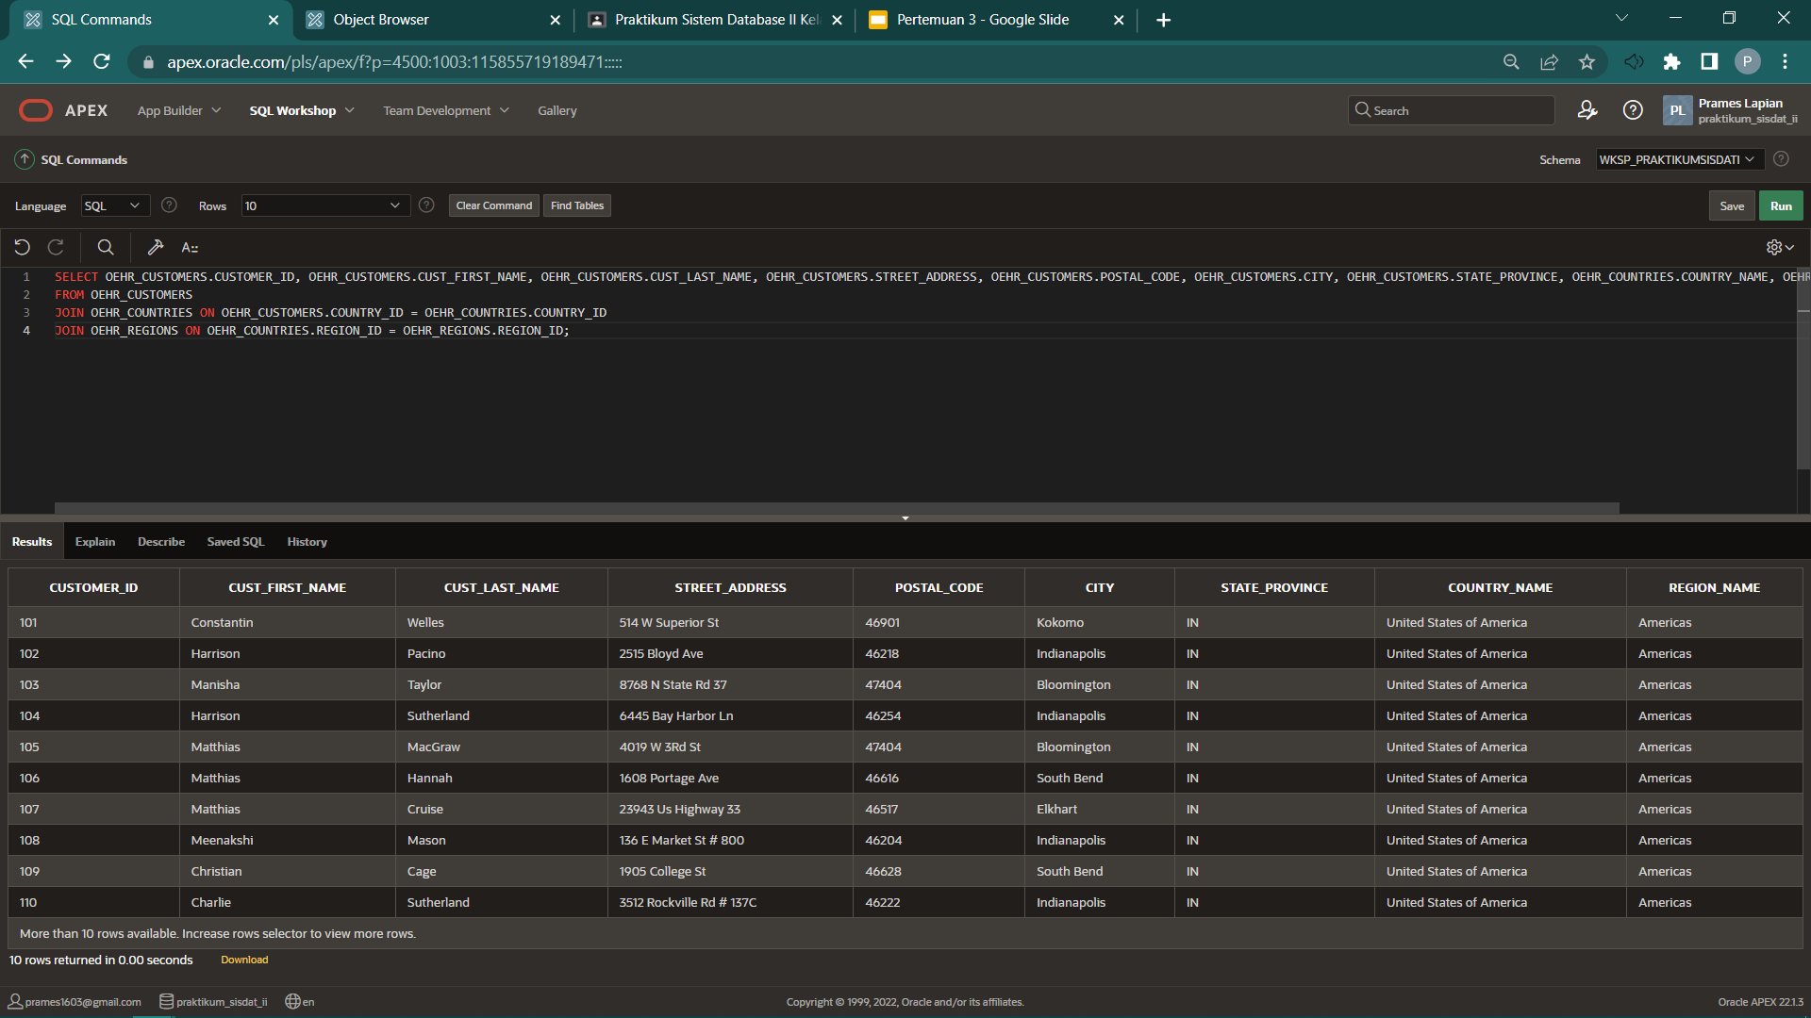

1. Cari karyawan/employee yang tidak memiliki manajer menggunakan metode outer join.

SELECT OEHR_EMPLOYEES.EMPLOYEE_ID, OEHR_EMPLOYEES.FIRST_NAME, OEHR_EMPLOYEES.DEPARTMENT_ID, OEHR_EMPLOYEES.MANAGER_ID AS "MANAGER_FIRST_NAME", OEHR_DEPARTMENTS.MANAGER_ID

FROM OEHR_EMPLOYEES

LEFT OUTER JOIN OEHR_DEPARTMENTS

ON (OEHR_DEPARTMENTS.MANAGER_ID = OEHR_EMPLOYEES.MANAGER_ID)

WHERE (ROWNUM <= 1);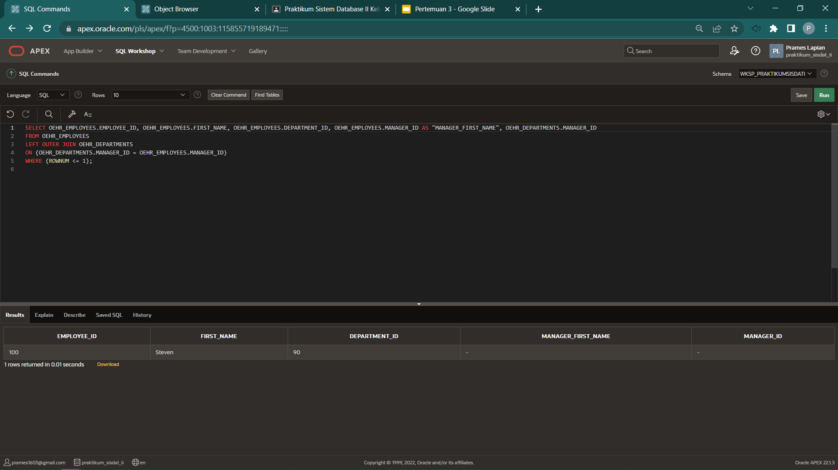

1. Hitung jumlah karyawan berdasarkan job_id

SELECT JOB_ID, COUNT(*)

FROM OEHR_EMPLOYEES

GROUP BY JOB_ID;